Guidelines:
- The policy project is your only assignment for the exam; the oral exam will be a discussion of your project. So, take this project seriously!
- The project is made of: 1 short essay (max 3500); 1 ppt presentation
- You can reach me by email asking specific questions whenever needed. Further, you can send me your draft for review ONCE before the 20th of December. I will provide my comments within one-two weeks.
- Your final project is due 3 DAYS BEFORE THE EXAM SESSION. It can be discussed in any of the exam sessions but it is strongly recommended to have one collective sessions. As usually, you will need to register to take the exam.
- Follow the template below. The main sections and the contents/subsections are mandatory. Word numbers are an approximation (+/- 200 words). You are free to use whatever editing format you like.
- For the exam, please prepare a ppt to be presented the day of your exam. No need to send it before the exam. You will have 10 minutes to present your project, so focus on the main points.
- English is a plus.

Title
Find a catchy title. Remember that you are always competing for resources against other proposals.

Abstract (Max 250 words)
Convey the main messages, skip the details.

1. The policy problem (max. 1500 words; Google scholar is a good search engine for this section)
- Exploring the problem. Data, information, evidence, literature on the causes, consequences and nature of your problem. The chapter in Dunn’s book has some tools that can be useful. Try to locate your problem in the structured/unstructured diagram and investigate the causal drivers of the problem (causal map).
- Stakeholder mapping. A preliminary presentation of the subjects involved in the problem, their specific understanding of it and their pet solutions. It is good to have a summary table and more in-depth discussion.
- Good-practice research: survey existing solutions to your problem and scout possible ideas to be imported in your case.

2. Developing a solution (Max. 1500)
- Policy tools. Use the tools matrix (types of goals/government resources) to explore the possible solutions to your problem. Describe the tools in the different categories. All the possible tools that come to your mind should be listed here.
- Theory of change. Provide a causal understanding of your proposal(s) and refine its details: who are the actors involved? How do they react to the policy? How can you make them change their behaviour? Which are the risks and counter-behaviours to be expected? Represent in a diagram the theory of change/mechanism, i.e. how your policy is supposed work. Use these results to refine your policy design. Draw the theory of change/mechanism for at least 2 interventions in your ‘policy tools’ matrix.
An example of theory of change:
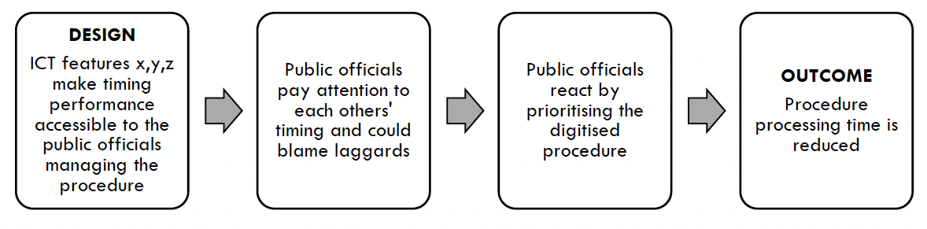
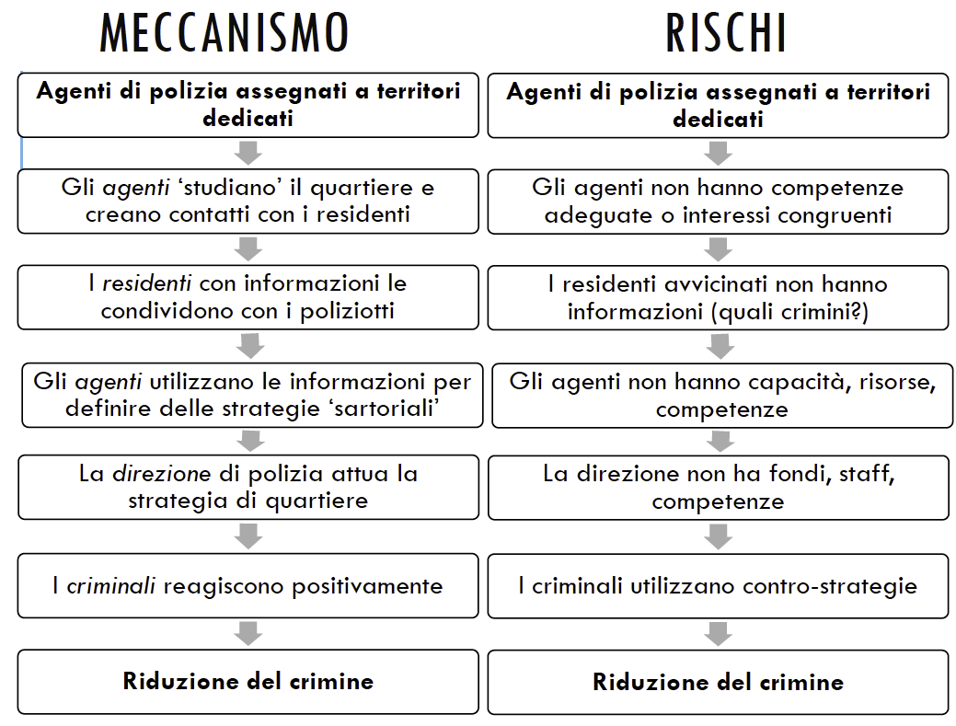

- Present your proposal! Provide a brief description of your final proposal and tell why you chose this specific project and those specific tools/interventions (you can refer to the outcome matrix in Bardach’s book if you think it is useful).

3. Decisional process (max 1500 words)
- Actors’ analysis. Which are the actors plausibly involved (interested actors)? Which actors are needed for a successful decision (potential allies)? Are there actors that are needed but who are not willing to participate (neutral)? Are there actors that are openly opposed to your project opposers)? Complete the following tables:
Table 1 Matrice Attori
ACTOR | GOALS | TYPE of Actor | Resources | Role
Actor A | Content-related goals / Process-related goals | Experts, politicians, bureaucrats, special interests, general interests | Political, Legal, Knowledge, Economic | Ally, Opposer, Director, Promoter, Gatekeeper
Actor B
Actor C
Actor n…

Table 2 Analisi della complessità del processo
Type of actors / Territorial level | Politicians | Bureaucrats | Special Interests | General Interests | Experts
Supranational
National
Regional
Municipal
Local

- Analysis of the stake.
- 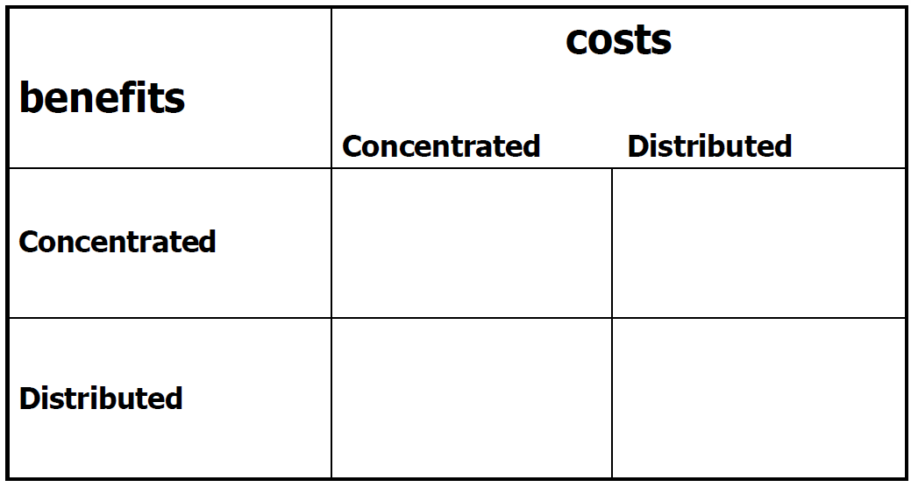

- Network Analysis. Draw the network of actors involved in the process (there are several software solutions for network analysis – see for instance UCInet)

- Decision strategy. Is there any way to overcome decisional problems?

References
Insert only articles, books and documents quoted in the text. In-text references should take this format: (Campolongo, 2019) or – if you are citing part of a text you need to put also the page of the quotation (Carletti, 2020: 130). If there are two authors then it is: (Campolongo & Carletti, 2019) and if you have three or more authors you just put the first one (Campolongo et Al, 2019).
References in this sections should be reported in alphabetical order with different formats depending if it is a book, scientific article, or an article/document available online:
Book example: Di Zio, M. (2018) Boosting Waste Recycling in Montesilvano, Oxford University Press.
Journal article example: Di Lorenzo, P. (2020) Tackling tax evasion in Italy, in Fiscal studies, Vol 6: 112-122.
Online article example: Carrella, F. (2019) Perché i Rom a Pescara non sono il problema, Il Foglio, 15/12/2019, available at www.ilfoglio.it/xyz [accessed 10/10/2020].
Policy report examples:
Campolongo, A., Carletti, G. & Di Zio, M. (2010) Tertiary education in Italy: The case of public policy analysis, OECD, available at www.oecd.org/xyz
OECD (2010) Tertiary education in Italy: The case of public policy analysis, available at www.oecd.org/xyz

