Europe said it was pandemic-redy. Pride was its downfall

The coronavirus exposed European countries’ misplaced confidence in faulty models, bureaucratic busywork and their own wealth.
By David D. Kirkpatrick, Matt Apuzzo and Selam Gebrekidan
July 20, 2020, NYT

LONDON — Prof. Chris Whitty, Britain’s chief medical adviser, stood before an auditorium in a London museum two years ago cataloging deadly epidemics.
From the Black Death of the 14th century to cholera in war-torn Yemen, it was a baleful history. But Professor Whitty, who had spent most of his career fighting infectious diseases in Africa, was reassuring. Britain, he said, had a special protection.
“Being rich,” he explained.
Wealth “massively hardens a society against epidemics,” he argued, and quality of life — food, housing, water and health care — was more effective than any medicine at stopping the diseases that ravaged the developing world.
Professor Whitty’s confidence was hardly unique. As recently as February, when European health ministers met in Brussels to discuss the novel coronavirus emerging in China, they commended their own health systems and promised to send aid to poor and developing countries.
“Responsibility is incumbent on us, not only for Italy and Europe, but also for the African continent,” said Roberto Speranza, Italy’s health minister.
“The European Union should be ready for support,” agreed Maggie De Block, Belgium’s then health minister.
Barely a month later, the continent was overwhelmed. Instead of serving simply as a donor, providing aid to former colonies, Western Europe became an epicenter of the pandemic. Officials once boastful about their preparedness were frantically trying to secure protective gear and materials for tests, as death rates soared in Britain, France, Spain, Italy and Belgium.
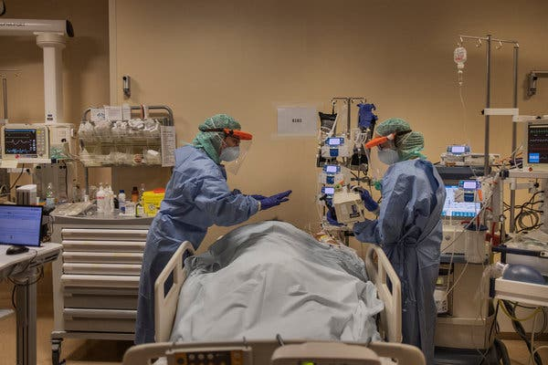
Image
Tending to a coronavirus patient in a hospital in Bergamo, part of a wealthy Italian region hit hard and early by the pandemic, in March.Credit...Fabio Bucciarelli for The New York Times
This was not supposed to happen. The expertise and resources of Western Europe were expected to provide the antidote to viral outbreaks flowing out of poorer regions. Many European leaders felt so secure after the last pandemic — the 2009 swine flu — that they scaled back stockpiles of equipment and faulted medical experts for overreacting.
But that confidence would prove their undoing. Their pandemic plans were built on a litany of miscalculations and false assumptions. European leaders boasted of the superiority of their world-class health systems but had weakened them with a decade of cutbacks. When Covid-19 arrived, those systems were unable to test widely enough to see the peak coming — or to guarantee the safety of health care workers after it hit.
Accountability mechanisms proved toothless. Thousands of pages of national pandemic planning turned out to be little more than exercises in bureaucratic busy work. Officials in some countries barely consulted their plans; in other countries, leaders ignored warnings about how quickly a virus could spread.
European Union checks of each country’s readiness had become rituals of self-congratulation. Mathematical models used to predict pandemic spreads — and to shape government policy — fed a false sense of security.
National stockpiles of medical supplies were revealed to exist mostly on paper, consisting in large part of “just in time” contracts with manufacturers in China. European planners overlooked the risk that a pandemic, by its global nature, could disrupt those supply chains. National wealth was powerless against worldwide shortages.
Held in high esteem for its scientific expertise, Europe, especially Britain, has long educated many of the best medical students from Asia, Africa and Latin America. On a visit to South Korea after a 2015 outbreak of the coronavirus MERS, Dame Sally Davies, then England’s chief medical officer, was revered as an expert. Upon her return home, she assured colleagues that such an outbreak could not happen in Britain’s public health system.
Now South Korea, with a death toll below 300, is a paragon of success against the pandemic. Many epidemiologists there are dumbfounded at the mess made by their mentors.
“It has come as a bit of a shock to a number of Koreans,” said Prof. Seo Yong-seok of Seoul National University, suggesting that perhaps British policymakers “thought that an epidemic is a disease that only occurs in developing countries.”
Not every Western democracy stumbled. Germany, with a prime minister trained in physics and a sizable domestic biotech sector, managed it better than most. Greece, with fewer resources, has reported fewer than 200 deaths. But with several countries expected to conduct public inquests into what went wrong, Europe is grappling with how a continent considered among the most advanced failed so miserably.
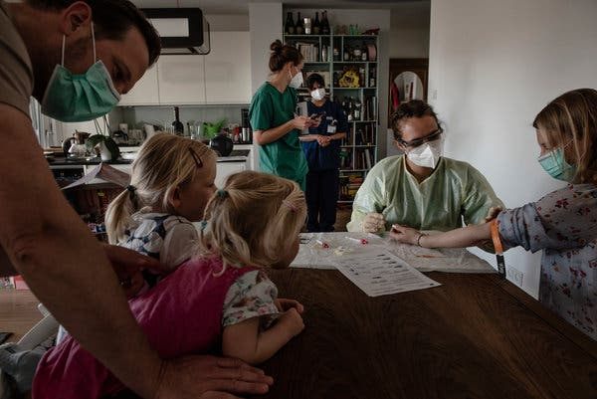
Image

Taking blood as part of a random sampling for antibodies to the coronavirus in Munich in April.Credit...Laetitia Vancon for The New York Times
Its downfall presaged the chaos now unfolding in the United States, where President Trump initially responded to the pandemic by blaming continental Europe and cutting off travel. “No nation is more prepared or more resilient than the United States,” he declared on March 11, assuring Americans that “the risk is very, very low.”
“The virus will not have a chance against us,” Mr. Trump said.
Today, the United States has the highest number of cases in the world and a death rate that is again rising, closing in on the European nations already humbled by the virus.
Belgium, by some measures, has the world’s highest death rate. Italy’s wealthiest region was shattered. France’s much-praised health system was reduced to relying on military helicopters to rescue patients from overcrowded hospitals. Britain, though, most embodies Europe’s miscalculations because of the country’s great pride in its expertise and readiness.
Prime Minister Boris Johnson was so confident that Britain’s modelers could forecast the epidemic with precision, records and testimony show, that he delayed locking down the country for days or weeks after most of Europe. He waited until two weeks after British emergency rooms began to buckle under the strain.
With the number of infections doubling every three days at the time, some scientists now say that locking down a week sooner might have saved 30,000 lives.
Dr. Whitty, 54, initially praised in British newspapers as the reassuring “geek-in-chief,” has declined to speak publicly about his role in those decisions. His friends say the government has set him up to take the blame.
“The politicians say they are ‘following the science’ and then if they make the wrong decisions it is on him,” said Prof. David Mabey of the London School of Hygiene and Tropical Medicine, a friend and colleague. “I am not sure the politicians listen to him.”
Critics, though, say it is impossible to absolve the government’s scientific advisers of shared responsibility.
“They thought they could be more clever than other countries,” said Prof. Devi Sridhar, an epidemiologist at the University of Edinburgh. “They thought they could outsmart the virus.”
Sir David King, a former British chief science officer, said, “The word ‘arrogance’ comes to mind, I am afraid.” He added: “What hubris.”
Fear swept the continent. It was spring of 2009 and a new virus that became known as swine flu had infected hundreds and killed dozens in Mexico. European vacationers swarmed airports to get home. Experts recalled the flu pandemic of 1918, which killed as many as 50 million people around the world.
European governments sprang into action. France asked the European Union to cut off travel to Mexico and began buying doses of vaccine for everyone in the country. British hospitals enlisted retired health workers and distributed stockpiled masks, gloves and aprons.
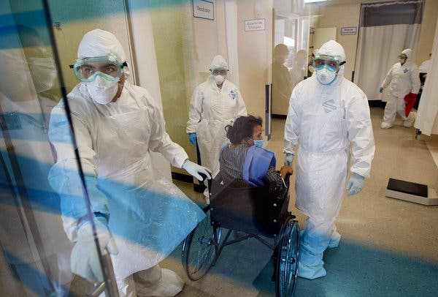
Image

Doctors tending to a patients complaining of Swine Flu-like symptoms in Mexico City in 2009.Credit...Joe Raedle/Getty Images
Every country in Europe had drawn up and rehearsed its own detailed pandemic plan, often running into the hundreds of pages. Britain’s plans read like the script of a horror movie, if written in the language of a bureaucrat. More than 1.3 million people could be hospitalized and 800,000 could die. Trying to contain the pandemic “would be a waste of public health resources.”
These doomsday scenarios drew on a new subspecialty of epidemiology pioneered by British scientists: using abstruse mathematical models to project the path of a contagious disease.
One early disciple, Neil Ferguson of Imperial College London, had assumed a pre-eminence in British health policy. Professor Ferguson was an Oxford-trained physicist who shifted to mathematical epidemiology in the 1990s, after watching a close friend’s brother die of AIDS.
Other scientific advisers say Professor Ferguson, now 52, stands out for his self-assured style in delivering easy-to-understand answers under enormous time pressure.
“He is able to answer questions succinctly and clearly and with a very measured conclusion, and it is exactly the sort of information that politicians need,” said Peter Openshaw, a professor of medicine at Imperial College London who sits with Professor Ferguson on a panel that advises the government on respiratory viruses.
Traditional public health experts, emphasizing clinical experience and field observations, were skeptical. They warned that the projections were only as good as their data and assumptions, and that policymakers without a background in math might treat models as dependable predictions.
An epidemic of foot-and-mouth disease among livestock in Britain in 2001 was the first time policymakers relied on such modeling while addressing an outbreak. Over the objections of veterinarians, Professor Ferguson’s work guided policymakers to preventively slaughter more than six million pigs, sheep and cattle.
Later studies concluded most of the killing was needless. A review commissioned by the government urged that policymakers “must not rely on the model to make a decision for them.”
“‘Muddlers,’ we call them,” said Alex Donaldson, then head of Britain’s Pirbright Laboratory of the Institute for Animal Health. “In future epidemics the first thing that should be done is to lock up the predictive modelers.”
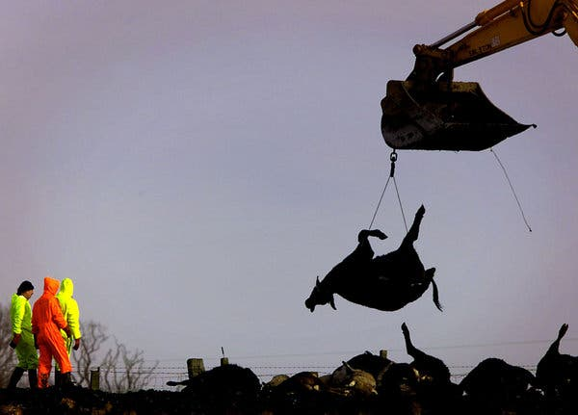
Preparing slaughtered pigs and cows for the incinerator at a farm in northern England during the 2001 foot-and-mouth disease outbreak.Credit...Jeff J. Mitchell/Reuters
Yet when swine flu emerged, British leaders again turned to Professor Ferguson and the large modeling department he had built at Imperial College. He projected that swine flu, in a reasonable worst case, could kill nearly 70,000.
Elected officials were horrified. Boris Johnson, then mayor of London, presided over frantic meetings bracing for the absence from work of nearly half the city’s police officers and subway drivers.
“It is impossible to say how bad it will be,” Mr. Johnson warned soberly.
But the modelers’ “reasonable worst case” was wildly off. Swine flu ended up killing fewer than 500 people in Britain, less than in a seasonal flu. Dr. Catherine Snelson, then completing her training in critical care at a hospital in Birmingham, had been assigned to help transfer out excess patients.
“We actually sat there doing nothing,” she recalled.
For Mr. Johnson, the swine flu episode reinforced instincts not to impose restrictions in the name of public health.
“He believes people will make the right decisions on their own,” said Victoria Borwick, a former deputy mayor.
An official review cautioned: “Modelers are not ‘court astrologers.’”
Some experts now say Europe learned the wrong lesson from the swine flu.
“It created some kind of complacency,” said Prof. Steven Van Gucht, a virologist involved in the Belgian response. “Oh, a pandemic again? We have a good health system. We can cope with this.”
It also coincided with Europe’s worst economic slump in decades. French legislators were furious at the cost of buying millions of doses of vaccines and faulted the government for needlessly stockpiling more than 1.7 billion protective masks.
To cut costs, France, Britain and other governments shifted more of their stockpiles to “just in time” contracts. Health officials assumed that even in a crisis they could buy what they needed on the international market, typically from China, which manufactures more than half the world’s masks.
By the start of 2020, France’s supply of masks had fallen by more than 90 percent, to just 150 million.
“The idea of a government warehousing medical supplies came to seem outdated,” said Francis Delattre, a French senator who raised alarms about dependence on China. “Our fate was put into the hands of a foreign dictatorship.”
“France has a superiority complex,” Mr. Delattre added, “especially when it comes to the health sector.”
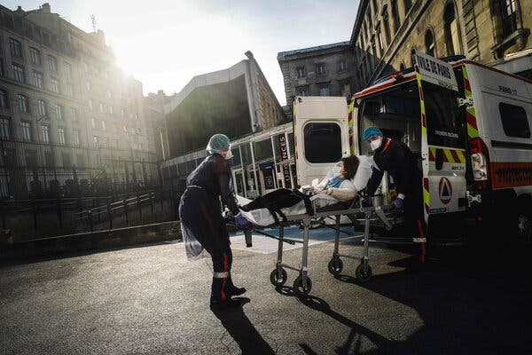

French first aid workers carrying a woman suspected of being infected with coronavirus in Paris in April.Credit...Lucas Barioulet/Agence France-Presse — Getty Images
Two years after swine flu, Britain scattered three quarters of its spending for public health to local governments, where it was harder to track and more easily diverted. Four hundred health experts warned in an open letter that decentralization would “disrupt, fragment and weaken the country’s public health capabilities,” and in the following years per capita spending on public health steadily declined. A national network that had once included 52 laboratories was eventually reduced to two national facilities and a handful of regional centers primarily serving the internal needs of regional hospitals.
Health officials also chose to limit stockpiles of protective equipment to deal with an influenza outbreak: enough for use during certain procedures in hospitals, but not for more general use, emergency rooms, doctors’ offices, or nursing homes.
Scientists knew a coronavirus like SARS or MERS could require more equipment.
“It’s pretty difficult to build a stockpile for something you’ve not seen before,” said Dr. Ben Killingley, an infectious disease expert who advises the government on what to stockpile. “It depends how much you want to spend on your insurance.”
On the surface, Europe’s defenses still looked robust. European Union reviews of each country’s pandemic readiness seemed to provide oversight, but the process was misleading.
National governments barred the European Centre for Disease Prevention and Control from setting benchmarks or pointing out deficiencies. So the agency’s public remarks were almost unfailingly positive. Britain, Spain and Greece were lauded for their “highly motivated experts,” “trusted expert organizations” and “confidence in the system.”
“We couldn’t say, ‘You should have this,’” said Arthur Bosman, a former agency trainer. “The advice and the assessment had to be phrased in an observation.”
European health officials recognized the vulnerability of national stockpiles. In response, the European Union in 2016 solicited bids to build a continent-wide repository. But the initiative fizzled because Britain, France and other large countries thought they had the situation covered. Belgium later destroyed tens of millions of expired masks from its own stockpile and never replaced them.
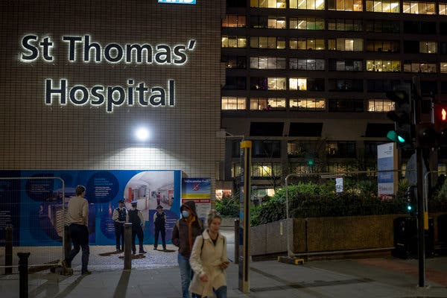
Image

A police guard outside St Thomas’ Hospital in London, where Prime Minister Boris Johnson was in intensive care in April. After the swine flu outbreak, public health spending was shifted to local councils.Credit...Andrew Testa for The New York Times
In 2016, Britain tested its readiness in a drill called Exercise Cygnus. Nine hundred officials across the country participated in a make-believe response to a “swan flu” that had emerged in Thailand and killed more than 200,000 people in Britain.
The planners evidently never imagined that acquiring protective gear from abroad could present a problem. “Ordering arrangements in place” was assumed as part of the background.
Over all, the drill revealed that many British officials were unfamiliar with the country’s pandemic plans and unsure of their roles, according to participants and a final report.
“It showed a hollowing out of the government, inside the infrastructure,” said Prof. Robert Dingwall, a sociologist who advises the government on respiratory viruses and helped draft the plans. “And that was never corrected.”
Two years later, in the real world, health industry journals reported a Chinese government crackdown on pollution shuttered a factory that was providing 1.75 million protective aprons each week to British hospitals. Shortages rippled through the system. Newspapers declared an “apron crisis.”
No one apparently imagined what would happen to Europe if all Chinese supplies were choked off at once.
On Jan. 28, British scientists raised an alarm.
The expanding epidemic was setting off a global run on personal protective equipment, specifically on the face-covering mechanical hoods that provide the gold standard of safety.
A decision to stock up any later “could pose a risk in terms of availability,” warned the government’s respiratory virus advisory panel.
It is unclear when Britain began in earnest to try to augment its supplies of protective equipment.
The health ministry has said only that it began unspecified “discussions and orders” during the week beginning Jan. 27. But Matt Hancock, the health secretary, later acknowledged that by the time Britain began buying, the spike in global demand had made protective equipment “precious” and procurement “a huge challenge.”

Image
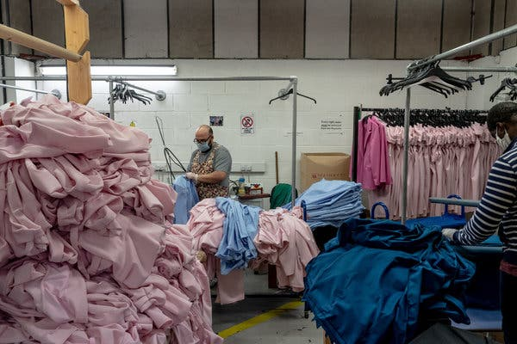
A clothing factory in north London switched production to make scrubs in an effort to help the British health care system cope with the coronavirus.Credit...Andrew Testa for The New York Times
The Doctors’ Association UK, an advocacy group, later said it received more than 1,300 complaints from doctors at more than 260 hospitals about inadequate protective equipment. At least 300 British health workers eventually died after contracting Covid-19.
“We worry that some died because of a lack of personal protective equipment,” said Dr. Rinesh Parmar, the group’s chairman. “It was very shortsighted to think that supply lines would continue to China.”
On the continent, governments that had resisted benchmarks from the European center for disease control now flooded the agency with desperate questions, including about what equipment to stock. The agency published a list of what was needed on Feb. 7, but by then global supplies had all but run out.
“It was already way more than what they could get their hands on,” said Dr. Agoritsa Baka, a senior doctor at the European center.
In Belgium, a shortage of masks became so desperate that King Philippe personally brokered a donation from the Chinese tech company Alibaba.
European and global health officials had thoroughly reviewed Belgium’s pandemic plan over the years. But when Covid-19 hit, Belgian officials did not even consult it.
“It has never been used,” said Dr. Emmanuel André, who was drafted to help lead the country’s coronavirus response.
In France, President Emmanuel Macron tacitly acknowledged the depletion of the government’s stockpile at the beginning of March by requisitioning all the masks in the country.
But he still insisted France was ready. “We are not going to stop life in France,” his spokeswoman assured radio listeners.
Ten days later, Mr. Macron declared a state of war and ordered a strict lockdown.
“I don’t understand why we were not prepared,” said Dr. Matthieu Lafaurie, of the Saint-Louis hospital in Paris. “It was very surprising that every country had to realize itself what was going on, as if they didn’t have the examples of other countries. ”
Image

A handout image provided by the French Ministry of Defense showed boxes containing millions of face masks the country ordered from China in March.Credit...French Ministry of Defense, via Shutterstock
In Britain, Mr. Johnson told the public to stay “confident and calm.” But, the same day, Feb. 11, the government’s Scientific Advisory Group for Emergencies, or SAGE, privately concluded that the country’s diminished public health system was incapable of widespread Covid-19 testing, even by the end of the year.
“It is not possible,” the group’s minutes note.
The British scientists and officials nonetheless thought they knew better than other countries like China and South Korea. Those countries were driving down the infection rate by imposing lockdowns. The British science advisers thought such restrictions were shortsighted. Unless the restrictions were permanent, any reduction of the epidemic would be lost to a “second peak,” SAGE concluded, according to its minutes and three participants.
Britain reported its first death from the virus on March 5. Across Europe, the number of confirmed cases was doubling every three days. Much of northern Italy was already locked down.
Testifying that day before a parliamentary committee, Professor Whitty, the chief medical adviser, was steady and comforting. Slightly hunched over a table in a small hearing room, he told lawmakers to place their trust in Britain’s modelers.
They were “the best in the world,” he said. “We will be able to model this out, as it starts to accelerate, with a fair degree of confidence.”
Despite alarming reports from Italy, he said, there was no way yet to predict the virus’s ultimate punch.
But he emphasized that Britain had “quite a long period” before the outbreak would peak, and said modeling would allow the government to wait until the latest possible moment before imposing social restrictions.
“We are keen not to intervene,” he said, “until the point when we absolutely have to.”
Mr. Johnson was even more sanguine. “It should be business as usual for the overwhelming majority of people,” he said that day in a television interview.
Image

Celebrating St Patrick’s Day in London. The British government did not issue a mandatory lockdown until six days later, on March 23.Credit...Mary Turner for The New York Times
But doctors in British hospitals were already feeling rising pressure. Intensive care wards were pushed to more than double their capacity in Birmingham, London and elsewhere.
“It became clear that the pandemic plan wasn’t going to cut it,” said Jonathan Brotherton, chief operating officer of University Hospitals Birmingham, England’s largest health system.
At an increasingly agitated SAGE meeting on March 10, the scientists concluded from the number of cases in intensive care units that there were at least 5,000 to 10,000 infections around the country.
“There will be thousands of deaths a day,” Professor Ferguson remembers warning surprised cabinet officials sitting in on a meeting.
Six days later, Professor Ferguson reported that SAGE’s modeling panel had moved up its projections. The peak was now almost at hand — within two weeks, at the beginning of April, not over the summer, as previously projected. Professor Ferguson released a public study that day that for the first time projected a potential British death toll in the hundreds of thousands.
Switching course, the committee urged sweeping social distancing measures, including school closures.
“It would be better to act early,” the group advised, according to minutes of the meeting.
Much of Europe, including France, had already shut down. Mr. Johnson waited another week, until March 23, to order a mandatory lockdown.

Britain, Spain, Belgium, France and Italy have now reported some of the highest per capita death tolls in the world. More than 30,000 people have died in France, and Mr. Macron has admitted his government was unprepared.
“This moment, let’s be honest, has revealed cracks, shortages,” he said.

Image
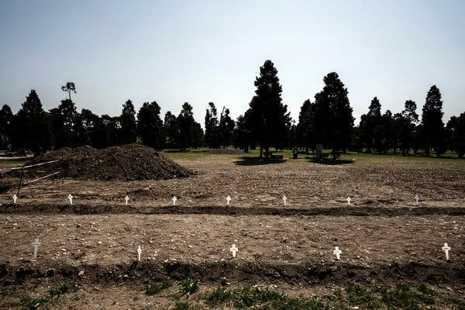
Victims of Covid-19 whose bodies had not been claimed were buried in a field at the Maggiore cemetery in Milan.Credit...Alessandro Grassani for The New York Times
After 44,000 coronavirus deaths in Britain, officials continue to defend their actions. The government’s response “allowed us to protect the vulnerable and ensured that the National Health Service was not overwhelmed even at the virus’ peak,” a health department spokesman said.
But Mr. Johnson has admitted that his government had responded “sluggishly,” like in “that recurring bad dream when you are telling your feet to run and your feet won’t move.”
Several scientific advisers have sought to distance themselves from his policies.
Professor Ferguson said in an interview that the decision not to intervene earlier was made by the government and health officials — not the modelers.
“They came back to us and say, ‘Can you model this? Can you model that?’” he said. “And we did.”
He insisted that he had warned privately in early March that Britain’s insufficient testing meant the scientists did not have enough information to track the epidemic.
Across Europe, he said, more testing “would have been the single thing which would have made the biggest difference.”

Image
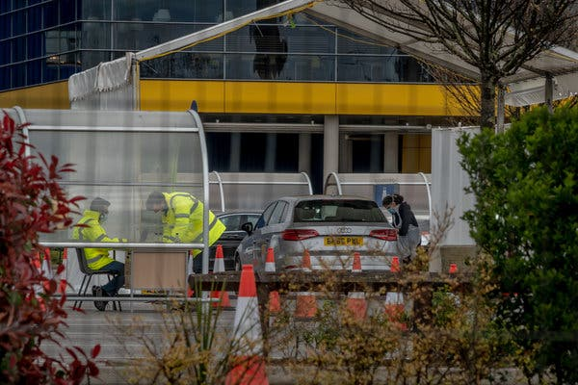
A drive-through coronavirus testing center in London.Credit...Andrew Testa for The New York Times
Other scientists say the intensive care reports in early March should have been reason enough to lock down without waiting for more testing or models. But there is another lesson to learn, said Dr. André, who spent years fighting epidemics in Africa before advising Belgium on the coronavirus.
“They keep on telling countries what they should do, very clearly. But all these experts, when it happens in your own countries? There’s nothing,” he said.
“One lesson to learn is humility.”
Monika Pronczuk contributed reporting from Brussels.
A version of this article appears in print on
July 20, 2020
, Section A, Page 1 of the New York edition with the headline: Sure of Pandemic Readiness, Europe’s Pride Preceded a Fall.

