**WESTERN BLOTTING**

Western blotting (or immunoblotting) is a well-established biochemical technique that detects specific proteins in complex samples and has applications from basic research to the diagnosis of infectious diseases. Western blotting can be used to determine quantity, molecular weight and post-translational modifications of proteins and can therefore be a powerful tool to monitor changes in proteins, including expression and modifications. Essentially, western blotting has three main elements: separate proteins in the sample by size, transfer to a solid support and visualize the target protein using primary and secondary antibodies.

**Solutions and Reagents**

***Lysis buffer: Radioimmunoprecipitation***

***assay buffer (RIPA buffer)***

50 mM Tris-HCl, pH 8.0

150 mM NaCl

1% Nonidet P-40 (NP-40) or 0.1% Triton X-100

0.5% sodium deoxycholate

0.1% sodium dodecyl sulphate (SDS)

1 mM sodium orthovanadate

1 mM NaF

Protease inhibitors tablet (Roche)

***Loading buffer: 2x Laemmli buffer***

4% SDS

10% 2-mercaptoethanol

20% glycerol

0.004% bromophenol blue

0.125 M Tris-HCl

Check the pH and adjust to pH 6.8 if necessary.

***Running buffer: Tris/Glycine/SDS***

25 mM Tris

190 mM glycine

0.1% SDS

***Transfer buffer***

25 mM Tris

190 mM glycine

20% methanol

For proteins larger than 80 kD, we recommend that

SDS be included at a final concentration of 0.1%.

***Ponceau S staining buffer***

0.2% (w/v) Ponceau S

5% glacial acetic acid

***Tris-buffered saline with Tween 20 (TBST) buffer***

20 mM Tris, pH 7.5

150 mM NaCl

0.1% Tween 20

**Procedure**

***Sample prep***

1. Place the cell culture dish in ice and wash the cells with ice-cold Tris-buffered saline (TBS).

2. Aspirate the TBS, then add ice-cold RIPA buffer (1 ml per 100 mm dish).

3. Scrape adherent cells off the dish using a cold plastic cell scraper and gently transfer the cell suspension into a precooled microcentrifuge tube.

4. Maintain constant agitation for 30 min at 4°C.

5. If necessary, sonicate 3 times for 10–15 sec to complete cell lysis and shear DNA to reduce sample viscosity.

6. Spin at 16,000 x g for 20 min in a 4°C precooled centrifuge.

7. Gently remove the centrifuge tube and place it on ice. Transfer the supernatant to a fresh tube, also kept on ice, and discard the pellet.

8. Remove a small volume (10–20 μl) of lysate to perform a protein assay. Determine the protein concentration for each cell lysate.

9. If necessary, aliquot the protein samples for long-term storage at –20°C. Repeated freeze and thaw cycles cause protein degradation and should be avoided.

**LET’S START FROM HERE**

10. Take 30 μg of BSA solution and add an equal volume of 2x Laemmli sample buffer.

11. Boil each sample in sample buffer at 95°C for 5 min.

12. Centrifuge at 16,000 x g in a microcentrifuge for 1 min.

**Polyacrylamide gel preparation**

Prepare a polyacrylamide gel depending on the size of the protein to be analyzed:

|  |  |
| --- | --- |
| **PROTEIN SIZE** | **GEL PERCENTAGE (ACRILAMIDE)** |
| > 200 KDa | 4 – 6 % |
| 50 – 200 KDa | 8% |
| 15 – 100 KDa | 10% |
| 10 – 70 KDa | 12.5% |
| 12 – 45 KDa | 15% |
| 4 – 40 KDa | Up to 20% |

***Note:*** *BSA has a weight of ~66,5 KDa*

**Resolving gel preparation**

|  |  |
| --- | --- |
| **GEL 12.5% (10 mL)** | |
| **REAGENTS** | **VOLUMES** |
| H2O | 6.6 mL |
| Acrilamide 30% | 8 mL |
| Tris-HCl 1.5M, pH 8.8 | 5 mL |
| 10% SDS | 0.2 µL |
| 10% APS | 0.2 µL |
| TEMED | 8 µL |

**Stacking gel preparation**

|  |  |
| --- | --- |
| **GEL 5% (2 mL)** | |
| **REAGENTS** | **VOLUMES** |
| H2O | 1.4 mL |
| Acrilamide 30% | 170 µL |
| Tris-HCl 1.5M, pH 8.8 | 130 µL |
| 10% SDS | 10 µL |
| 10% APS | 10 µL |
| TEMED | 1 µL |

**Protein separation by gel electrophoresis**

1. Load 10 µL of sample into the wells of a mini (8.6 x 6.7 cm) or midi (13.3 x 8.7 cm) format SDS PAGE gel, along with molecular weight markers.

2. Run the gel for 5 min at 50 V.

3. Increase the voltage to 100–150 V to finish the run in about 1 hr.

*Gel percentage selection depends on the size of the protein of interest. A 4–20% gradient gel separates proteins of all sizes very well.*

**Transferring the protein from the gel to the membrane**

1. Place the gel in 1x transfer buffer for 10–15 min.

2. Assemble the transfer sandwich and make sure no air bubbles are trapped in the sandwich. The blot should be on the cathode and the gel on the anode.

3. Place the cassette in the transfer tank and place an ice block in the tank.

4. Transfer overnight in a coldroom at a constant current of 10 mA.

**Note:** Transfer can also be done at 100 V for 30 min–2 hr, but the method needs to be optimized for proteins of different sizes.

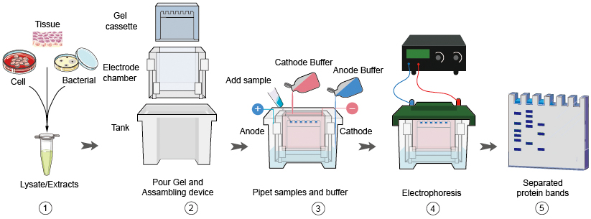

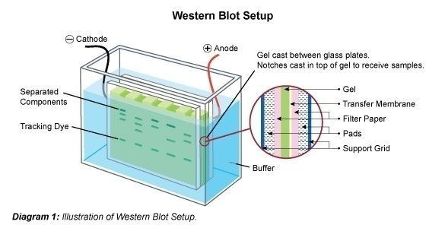

**Antibody incubation**

1. Briefly rinse the blot in water and stain it with Ponceau S solution to check the transfer quality.

2. Rinse off the Ponceau S stain with three washes with TBST.

3. Block in 3% BSA in TBST at room temperature for 1 hr.

4. Incubate overnight in the primary antibody solution against the target protein at 4°C.

**Note:** The antibody should be diluted in the blocking buffer according to the manufacturer’s recommended ratio. Primary antibody may be applied to the blot for 1–3 hr at room temperature depending on antibody quality and performance.

5. Rinse the blot 3–5 times for 5 min with TBST.

6. Incubate in the HRP-conjugated secondary antibody solution for 1 hr at room temperature.

**Note:** The antibody can be diluted using 5% skim milk in TBST.

7. Rinse the blot 3–5 times for 5 min with TBST.

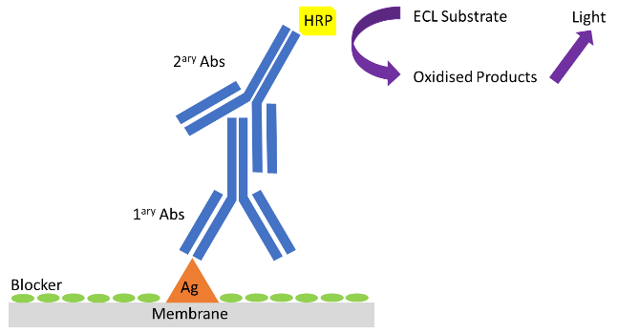

**Imaging and data analysis**

1. Apply the chemiluminescent substrate to the blot according to the manufacturer’s recommendation.

2. Capture the chemiluminescent signals using a CCD camera-based imager.

**Note:** The use of film is not recommended in this step because of its limited dynamic range.

3. Use image analysis software to read the band intensity of the target proteins.

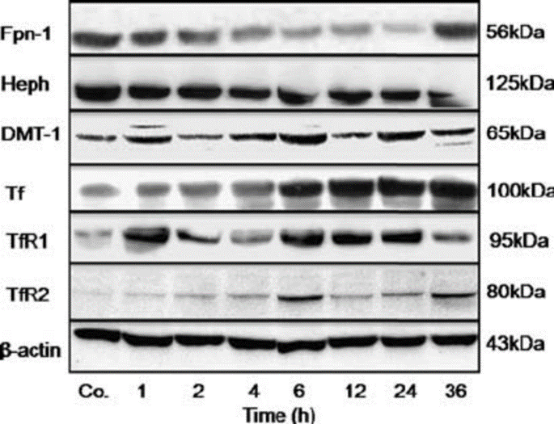

Example of an image analysis.