Epicuticular waxes protect the berry against light and heat stress. Although their main function is as transport barriers, they also play a role in protection against PAR and UV radiation by scattering, reflection, and even absorption, thus reducing exposure levels in the underlying tissues (Figure 8). The capacity of this layer to scatter light is dependent on the size, distribution, and orientation of the wax crystals. Plate-like wax crystals reflect and scatter a higher proportion of light than amorphous waxes (Jenks and Ashworth, 1999), while still allowing for transpiration (Muganu et al., 2011). Plate-like wax structures prevail in light- exposed grape berries of several varieties, while berries grown in the shade of the canopy have a higher proportion of amorphous waxes (Muganu et al., 2011). As sunburn symptoms appear, these waxes lose their crystalline structure and become relatively amorphous (Figure 8; Greer et al., 2006).
Sun-exposed berries have a thicker layer of epicuticular wax and overall thicker cell walls than shaded ones (Rosenquist and Morrison, 1989; Muganu et al., 2011; Verdenal et al., 2019), which relates to a higher capacity to reflect light (20–80% of incoming radiation when compared to shaded plants that only reflect 10%; Jenks and Ashworth, 1999)
It was recently demonstrated that grapes from drought-stressed vines also accumulate higher amounts of epicuticular wax than grapes from non-stressed vines (Dimopoulos et al., 2020), potentially increasing resistance to high-light conditions.
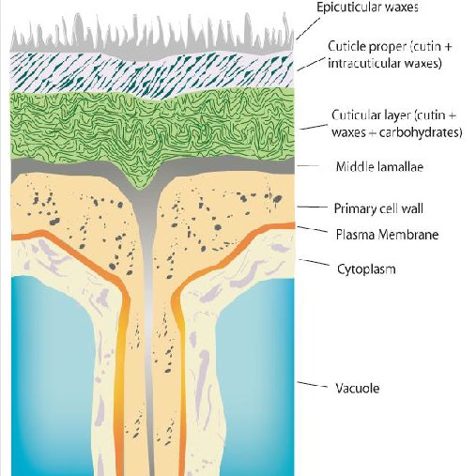

“Epicuticular wax, often referred to as “bloom,” covers the surface of the cuticle as overlapping platelets forming a strongly hydrophobic layer that protects the berry from water loss and forms the first barrier against pathogen invasion (Grncarevic and Radler, 1971; Possingham et al., 1967; Rosenquist and Morrison, 1988)”

